Module 2 Discussion

Using the 100 Things Every Designer Should Know About People reading assignment, select two (2) of the "things" you read about, include the number and title of the "thing" (i.e., #36 Time is Relative) , and then do two embellishments, one embellishment and one visual example, or two visual examples.
- Embellish: Tell us something that the reading did not tell us on that specific "thing" or embellish on what was presented. Be sure you are adding meaningful content to the conversation and not just making noise. Your addition can be a link to an article, or you can write out your embellishment.
- Visual Example: Provide us with a graphic example that is relevant to web design. This can be something you create or something you find. Again, be sure to add meaningful content to the conversation.

Topic: Reading a Screen is Harder than Reading Paper
Embellishment:
My embellishment on this one will be a counterpoint. The book says, “White text on a black screen is hard to read.” I have found personally that the opposite is true for me. This highlights a key difference that can vary from person to person. The reason I prefer a black screen with white letters is that the screen is not bright (and my eyes are sensitive to bright lights due to astigmatism), so it doesn’t hurt my eyes as much. This is why, on ALL of my devices, I have nearly everything set to “dark mode” or “night mode” so that I get a black screen with white text. If I screenshotted my computer now as I typed this, you would see that even Word has a black screen with white text. This is why the option can be so important! Websites and apps that allow for dark mode make me happy!
This speaks to the accessibility of web design and app design. Not everyone will see and perceive things in the same way (I think one topic in Module One had to do with color blindness, which is similar). Having options to choose from allows a user to customize their display appearance, especially for a website or application they will be using constantly, making a significant difference for that person.
Visual Example:
My visual example will be GitHub. Their website allows you to enable Dark Mode and even lets you select different themes within those modes. These themes are designed to allow for proper contrast, making the text readable (e.g., avoiding navy blue on a black background or light pink on a white one). Sometimes, places allow you to set the colors yourself, but that can also lead to issues if the user sets unreadable combinations.
GitHub also allows you to “Sync with the System,” a standard option now as well. This reads what theme your system uses (typically dark or light), and defaults to that.
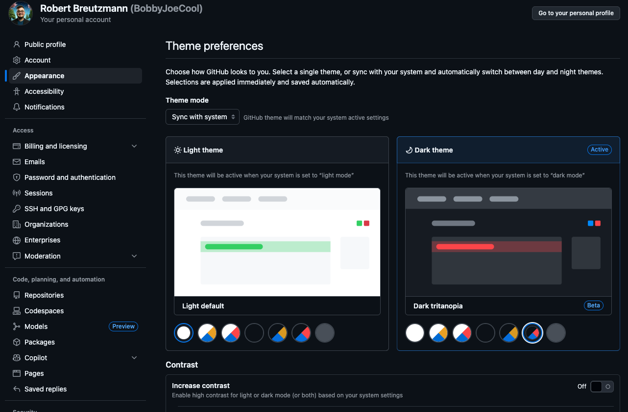
  - Image Credit: Screenshot of my GitHub Appearance Settings page.

